Lesson 24: Applications of Systems of Equations and Inequalities
Classwork
Opening Exercise
In Lewis Carroll’s Through the Looking Glass, Tweedledum says, “The sum of your weight and twice mine is 361 pounds.” Tweedledee replies, “The sum of your weight and twice mine is 362 pounds.” Find both of their weights.

Example 1
Lulu tells her little brother, Jack, that she is holding 20 coins all of which are dimes and quarters. They have a value of $4.10. She says she will give him the coins if he can tell her how many of each she is holding. Solve this problem for Jack.
 | Quarters | Dimes | Total
# of Coins
Value of Coins

Example 2
Bryce and his sister Julia each have a savings account for college. In April, Bryce’s account had a balance of $2000 and he plans to deposit an additional $50 per month. At the same time, Julia’s account had a balance of $1600 and she plans to deposit $100 per month. When will Bryce and Julia have the same amount in their college accounts?
Show the results using the grid below.

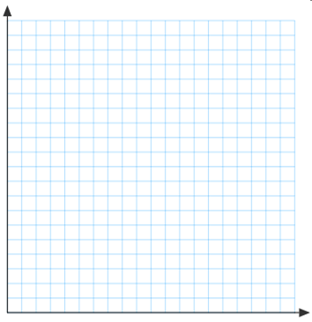

Example 3
292 tickets were sold for a high school basketball game. An adult ticket costs $3. A student ticket costs $1.
Ticket sales were $470. Find the number of adult and student tickets sold.

 | Adult | Student | Total
# of Tickets
Cost of Tickets

Problem Set

- Find two numbers such that the sum of the first and three times the second is 5 and the sum of second and two times the first is 8.

- At an amusement park, the cost of 3 adult tickets and 4 children’s tickets is $126.50. Another customer paid $120.50 for 2 adult tickets and 5 children’s tickets. What is the price of each kind of ticket?

- Pam has two part time jobs. At one job, she works as a cashier and makes $8 per hour. At the second job, she works as a tutor and makes $12 per hour. One week she worked 30 hours and made $268. How many hours did she spend at each job?

- A store sells Brazilian coffee for $10 per lb. and Columbian coffee for $14 per lb. If they decide to make a 150-lb. blend of the two and sell it for $11 per lb., how much of each type of coffee should be used?

5. Andy’s Cab Service charges a $6 fee plus $0.50 per mile. His twin brother Randy starts a rival business where he charges $0.80 per mile, but does not charge a fee.
a. Write a cost equation for each cab service in
terms of the number of miles.

b. Graph both cost equations.

c. For what trip distances should a customer
use Andy’s Cab Service?

d. For what trip distances should a customer
use Randy’s Cab Service?

e. Justify your answer algebraically and show the location
of the solution on the graph.

